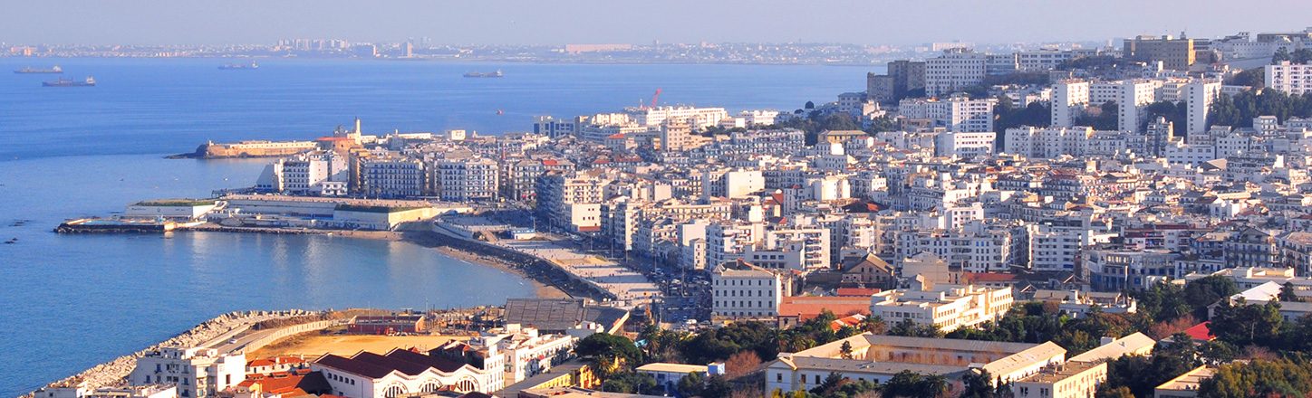

North Africa Practice

**OVERVIEW**

We have a unique team covering North Africa that offers the combination of international counsel and specialized local law advice, with more than 20 years of continuous experience in the region. Based in Paris, our North Africa dedicated team offers its clients an Algerian and French qualified lawyer at partner level together with an Arabic speaking team with genuine international experience. The team is led by partner Mehdi Haroun, admitted to the Paris and Algiers bar, who is recognized as one of the leading legal advisors for several North African countries by the highly regarded legal directories Chambers and Legal 500. Senior associate Nora Djeraba is a dual Algerian-French citizen who regularly works on North Africa matters and is considered as a rising star by Legal 500.

We advise, structure and negotiate large transactions on complex projects. Many of these projects are energy-based, from oil and gas, power, to complex infrastructures, including the construction of power plants and IPP/IWPP projects. We regularly advise international investors on various aspects of their operations in country, ranging from the structuring of their investment in the country, project development, services and contractor's agreements, to their day-to-day operations up until their exit from the country. The associated intricate investment issues are also an important part of our work.

Our team is deeply involved in each North Africa based litigation that King & Spalding works on, especially in the energy and infrastructure sectors. Some projects develop into a contentious relationship and our deep knowledge of the industry, the country and our worldwide reputation in disputes makes us the obvious choice for many clients. Our approach to dispute is to be problem solvers. We always seek out an amicable settlement first, often using our contacts in several strategic positions in the administration and government which places us in a unique position to find alternative solutions and negotiate settlements. Even when such an attempt initially fails, we use the leverage of the proceedings to extract the best value for our clients either through settlement in the course of the proceedings or out of the awards obtained. In North Africa, most dispute work relates to construction and investment, but we also deal with more specific types of disputes such gas price reopeners and hardship disputes. Mr. Haroun is the current vice-president of the Board of the Arbitration and Conciliation Center of the Franco-Arab Chamber of Commerce, and also occasionally represents clients before local Algerian courts.

*The team is ranked for Algeria, Tunisia and Libya and Africa-wide Projects & Energy*

Chambers Global 2020

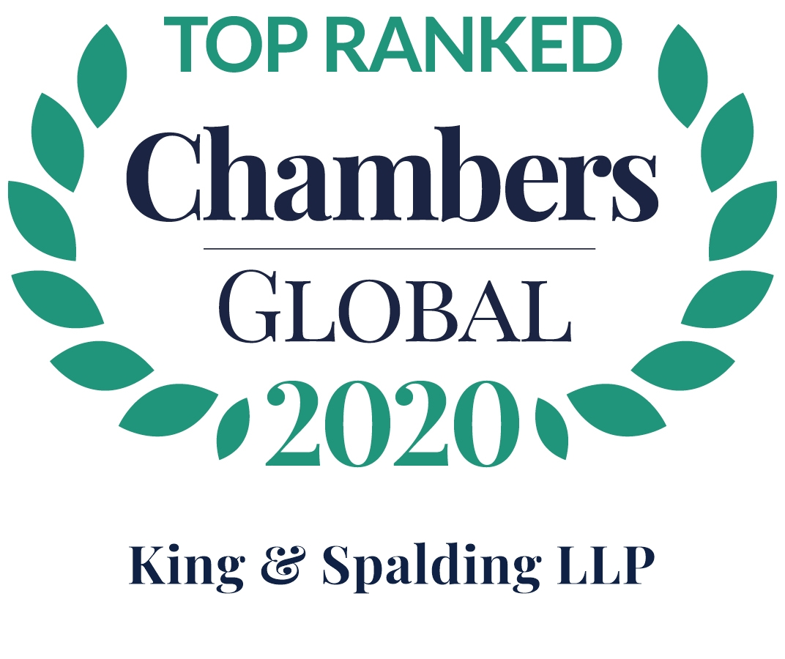

*“Thanks to practice head Mehdi Haroun, the group is one of the most sought-after teams for complex and highly sensitive oil and gas transactions in the North African region, especially in Algeria.”*

Legal 500 EMEA 2020



**REPRESENTATIVE MATTERS**

**Algeria**

* The team is advising Wintershall DEA on various legal aspects of the Reggane upstream developments in Algeria and more recently, the gas sales agreement relating to the Reggane gas field. In the current political and economic climate and with declining production and discoveries this project is of key importance to the country.
* We advised Anadarko on the change of control of their Algerian assets in relation to Anadarko’s acquisition by Occidental Petroleum, and advise them on their day to day operations on the Berkine Project, including contractual, employment, customs, regulatory, tax and social security issues.
* We are representing the EIIC group (EIIC, Bloom and their Algerian subsidiary) on an ICSID Dispute against the Algerian State in relation to the development of a mega leisure park and a real estate and commercial development project in Algiers.
* We represented Anadarko and Maersk Oil regarding an arbitration against Algeria's national oil company, Sonatrach, for breach of contract, and against the Algerian State for breach of a Bilateral Investment Treaty with Denmark, over the implementation of a windfall tax on exceptional oil profits, together with the negotiation of the related Settlement Agreement.

**Libya**

* We advised on all aspects of the transaction of the acquisition of Marathon’s interest in the Waha concession in Libya, from the due diligence to the tracking and negotiation of the SPA, the closing matters and post-closing matters. It was the largest upstream acquisition in Libya since the fall of the Gadhafi regime.

**Tunisia**

* We advised an oil & gas company on the acquisition of all ENI’s upstream assets in Tunisia, which comprised the oldest concession in the country, with several complex legal issues. After almost a year of work and the finalization of the negotiation of all the contract documents, the transaction did not proceed as the Government ultimately refused to approve the transfer.
* The team worked heavily on OMV’s upstream gas developments from the entry of OMV in the country and its acquisition of Pionneer’s assets (the largest ever upstream M&A deal in Tunisia) through its development. This included the negotiation and drafting of the Gas Sales Agreements with SPEG regarding the Adam and Cherouk concessions, the transportation agreements with ENI, and the development of the OMV managed gas transportation infrastructure, the Nawara gas pipeline.

**Morocco**

* We have been advising Chevron’s lubricant business since its entry in Morocco back in 2001. We have assisted during several renegotiations of the joint venture agreements, including the last renegotiation of the agreement with the Akwa group in the context of the increase of Chevron's participating interests in the Afriquia Lubrifiants JV and the extension of its operations to 14 countries in North and West Africa. This deal is a key turning point for the Akwa and Chevron Group in their cooperation in Africa globally.

*The team is ranked Tier 1 for Algeria, Corporate Commercial, with Mehdi Haroun a leading lawyer, and Nora Djeraba a rising star.*

*“Mehdi Haroun has deep in-country knowledge that goes beyond an understanding of the law and its application. Nora Djeraba is also highly regarded in this space.”*

Legal 500 EMEA 2020 (Algeria Corporate Commercial)

## CONTACTS

**Mehdi Haroun**

+33 1 7300 3984

mharoun@kslaw.com

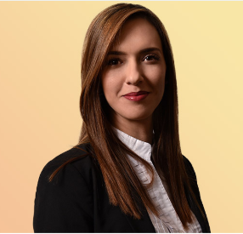

**Nora Djeraba**

+33 1 7300 3920

ndjeraba@kslaw.com